Experiment 2: Simulink Rx

DSP lab Spring 2013

2/19/2013

Jacobs University Bremen

Joshan Chaudhary & Grishma Raj Pandeya

1. **Explain briefly how the receiver works. Also, please highlight anything that was new that you didn't know before!**

Receiver has to reverse all the processes that we did in the transmitter in order to bring back the signal that we transmitted. Below is block-diagram showing main processes involved in receiver showing how the receiver works.

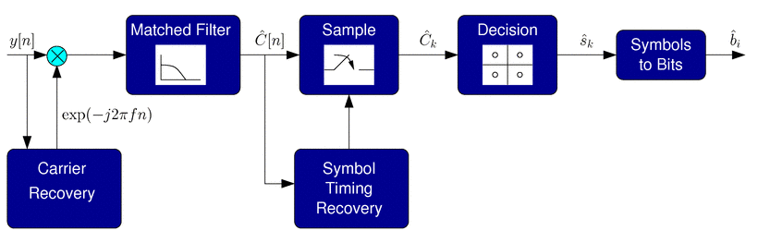

The basic operations involved in the process can be summed up in the following points

* We multiply the conjugate of the carrier to shift the signal back to baseband (zero center frequency)
* We apply a matched filter to remove the image at double the carrier frequency.
* We sample at the optimal points to obtain estimates of I/Q symbols weights.
* Based on the symbols we got above we make a decision which symbol was transmitted.
* We covert symbols back to the bits

**Multiplication Block:**

In the transmitter, we shift up the signal at higher frequency because we don’t transmit the signal at baseband. In the receiver we need to reverse this process i.e bring back the signal to baseband (zero center frequency). It is done by multiplying by the conjugate of the carrier that we used in the up-conversion.

**Matched filter:**

For simpler communications model, we could use a low pass filter to remove the doubled frequency component that we get from the multiply operation. But in more complicated designs (real systems) where noise is present we will have to use the same identical to transmit pulse-shaping filter and this is where we get the term “matched filter”.

**Sampler:**

In the sample block, the received waveform is sampled at the optimal points to get an estimate of the original I/Q symbol weights that were generated in the transmitter. In simulation it is easy to compute the delay required for optimal sampling. In a real communications system, the sampler block will need to be told when to sample hence the need for the symbol timing recovery block.

**Decision:**

Due to the presence of noise, the I/Q symbol weight estimates will not be exactly the same that we transmitted. So, we need a decision block to decide which symbol was most likely transmitted.

**Symbols to bits:**

This operation is just the reverse of what we did in the transmitter. We take a single symbol and map this to multiple bits.

The symbol timing recovery block is used to find out how much delay we have in our system so that we can sample at the right times to recover the transmitted symbols. Sampling at the wrong times may cause a loss of the transmitted signal. So this block in the receiver is a very useful one. The optimal sample points are obtained exploiting the excess bandwidth of the transmit signal to see the optimal sample points in the I/Q waveform. This can be achieved by locking a PLL to the rising and falling edges of the waveforms.

The new things that we learnt in this lab include first of all, how to create a subsystem which turned out to be a really handy tool. Because our work would have really gotten messy if not for the creation of a subsystem to house our transmitter system.

In the receiver communications chain, we learnt about an important concept which should definitely be considered if one wants to successfully receive the signal that was transmitted. This concept is synchronization. We found out that in simulation, one might not find synchronization useful because the relative delays can all be easily calculated and the carrier signal is also known from the transmitter chain. But in the real world, these important parameters are not known and then synchronization must be achieved. We learnt in our case that synchronization consist of carrier recovery and symbol timing recovery.

We also learnt about a phase-locked loop (PLL) which is a form of a tracking algorithm for sinusoidal signals. We saw how this PLL can be used to achieve synchronization.

We also learnt how to use the Fcn block to write our own user defined functions. We used this Fcn in the decision block.

**2. Explain how we can get a RC response by using root filters at the transmit receive. Explain why this is preferable to using just a single (non root) RC filter somewhere.**

The root filter is the square root equivalent of the RC response in the frequency domain. So, if we put one of this root filter at the transmit and the other at the receive then we get a RC equivalent response.

This is preferable to using just a single RC filter because it helps us to maintain the zero-ISI property. If the transmit and receive filter are of the same kind then we get optimal noise performance.

**3. Explain the need for synchronization in communications systems, and how this was accomplished in this lab. Also describe what a PLL is and what it can do. What are carrier and symbol timing recovery for?**

Synchronization is very important in communications systems. It helps us to find the carrier that was used in the up-conversion so that we can use it in the down conversion. It also helps in finding the symbol timing recovery. In the lab it was accomplished by adding pilot tone to the transmitted signal. The pilot tone was then extracted using a narrow bandpass filter and the carrier frequency was read from it. We also used the PLL for synchronization to extract the carrier frequency from the pilot tone. For the symbol timing recovery, we used a created block along with a sampler to achieve it.

The PLL, short form for Phase-locked loop, is a device that takes a sine wave as input and tracks its phase. It can be thought as a tracking algorithm for sinusoidal signals.

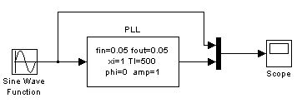

Fig: PLL

The PLL generates its own sine wave internally, whose phase is locked to the incoming signal. The PLL is also free to generate any other clock or sine wave signals that are needed based on this phase. For example, the PLL can generate a carrier with double or half the frequency, apply a constant phase shift, etc. The PLL can generate an output sine wave with the same frequency as the input or with the multiple of input frequency, or with amplitude different from the input but with the same phase.

Carrier recovery is for determining the carrier frequency of the transmitted signal for down conversion and symbol timing recovery is to find out the delay we have in our system so that we can sample at the right times to recover the transmitted symbols.

**4. Give plots showing the output of your communications system for two cases: (i) with perfect ideal synchronization, and (ii) with the synchronization blocks. Circle and label points the printout to "prove" to the TA that it is working.**

**Output with ideal synchronization**

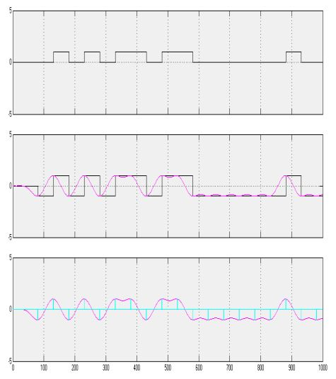

**With synchronization blocks**

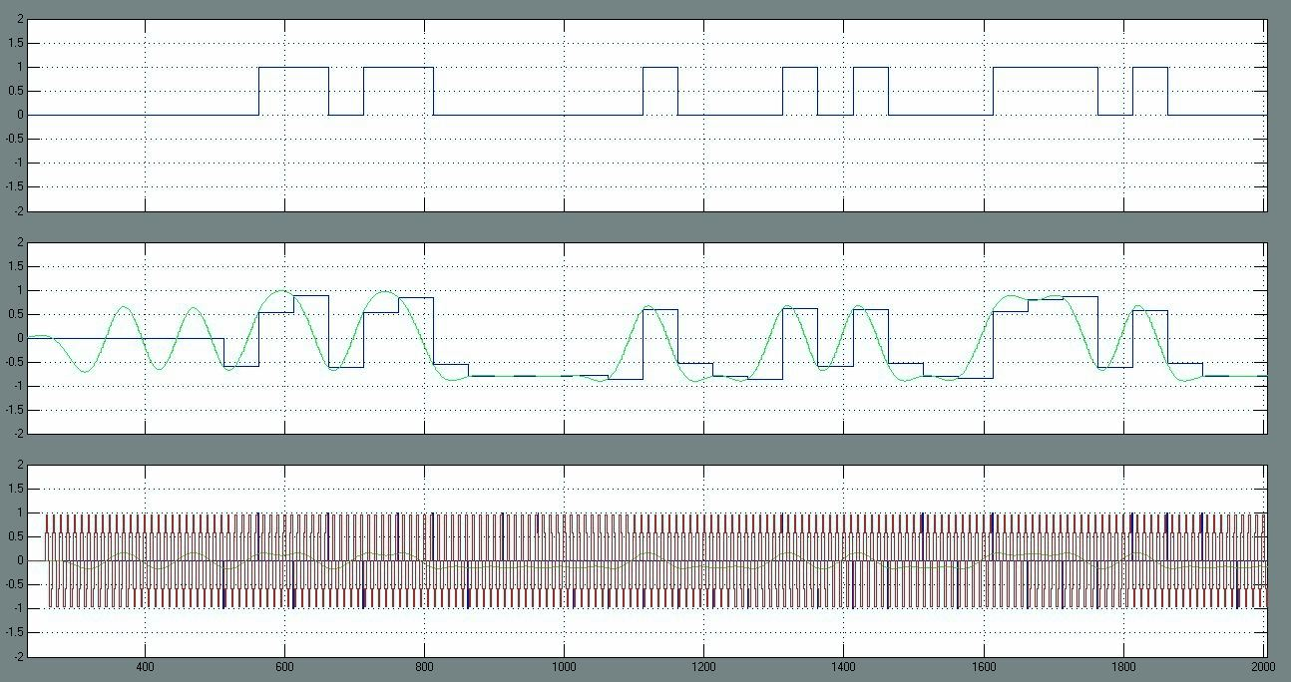

**5. Describe any difficulties you experienced in getting your design to work and how you fixed these problems.**

We were having difficulty with the delay elements. One of our simulink did not have the proper delay element and also we had some issues with getting the right delay element and our signals were not timed. Using the new blocks for the first time was a little bit of work and sometimes the circuit became confusing and tedious as it grew in size and complexity. Also, while trying the PLL for the first time we did not get the result we should get but it worked later on.

**Reference:**

**http://www.xwallace.com/courses/dsp**